Tim Edey’s closing concert at the 2023 Towersey folk festival received no less than two standing ovations… Watch that stunning clip, a lesson in the art of musical entertainment here;

TOWERSEY TIM EDEY STANDING OVATION
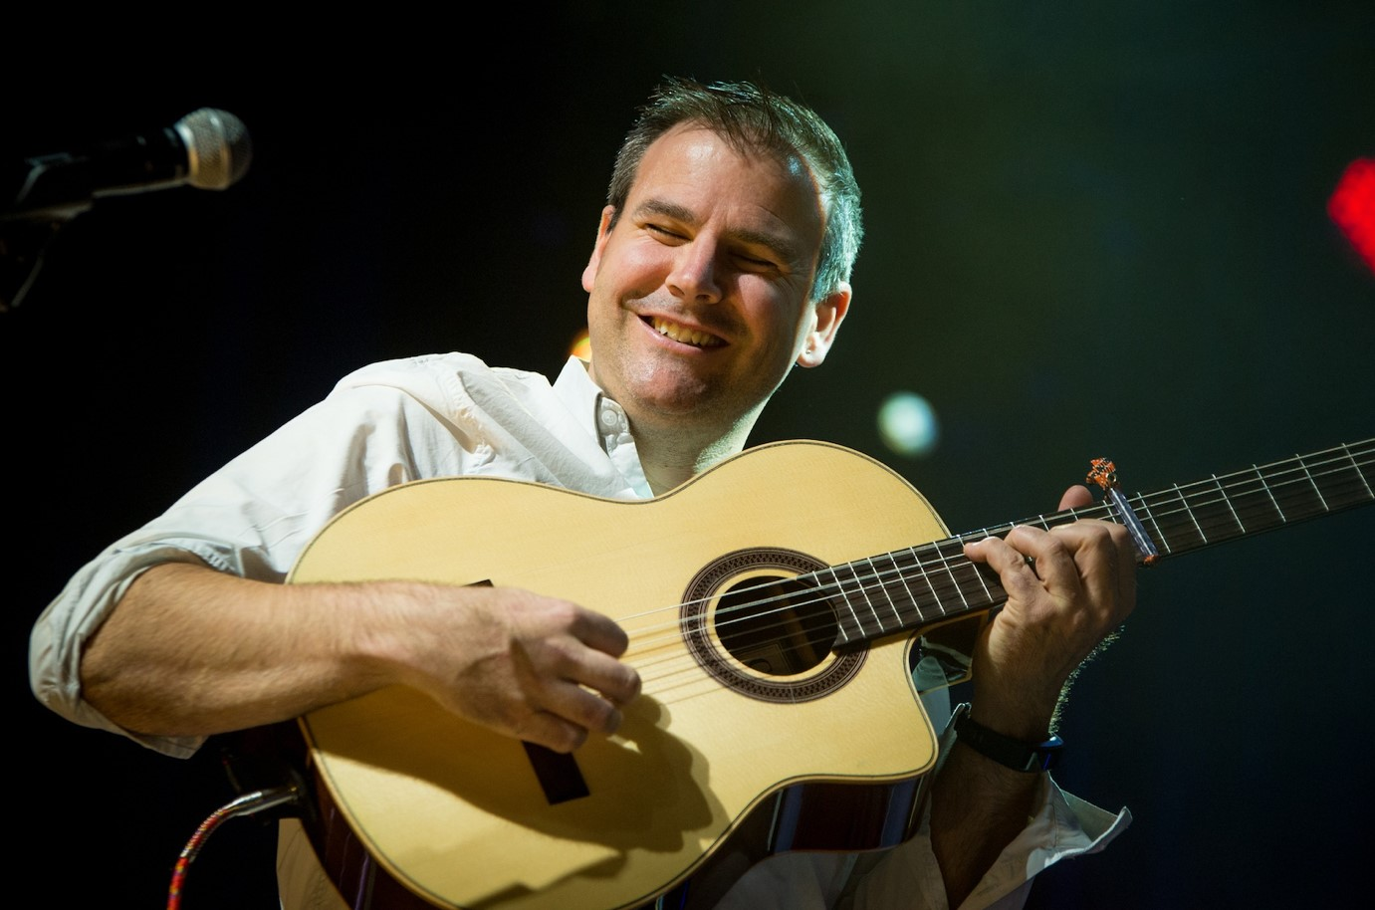

Tim brings remarkable musical virtuosity, along with his effervescent performance, engaging personality and a sense of fun – combining this with a show that celebrates the music of both the Celtic, folk tradition’s plus exciting gypsy jazz, classical, acoustic + pretty much any style of music that Tim feels like at the time.
“Tim sits between Donal Lunny and Steve Cooney… yes he’s that good!” PETE FYFE FOLKING.COM
In 2023 Tim played headline shows at major festivals including Priddy,
Broadstairs, Warwick, BLAS, Celtic Connections, Celtic Colours (Canada) and many more…
A fine singer in his own right too, here is “Winds & Tides” from Towersey 23 Song – Winds & Tides
“One of the world’s best melodeon players” Mike Harding
Pressed for time – Tim Edey - Melodeon

Tim needs no introduction to lovers of folk, roots and Celtic music, having performed with most of the major names in Irish and Scottish music, as a performer in his own right, a go-to musician for the likes of The Chieftains (2011-2019) and Sharon Shannon, Carlos Nunez and
Session A9 or his collaborations with a range of friends, such as renowned Scottish piper
Ross Ainslie and Kiwi harmonica maestro Brendan Power, plus legends such as Mike McGoldrick and Dougie McLean. Receiving a BBC Radio Folk Award 2012 and winning the BBC Scotland
BBC ALBA/SCOTLAND Musician of the Year in 2020 + BBC R2 FOLK AWARDS MUSICIAN OF THE YEAR 2012 are just two of his many accolades and confirmation of his standing in the industry with many more nominations.

A brand new album of songs and instrumental dexterity is due out in Spring
2024
Also, I have included links to a couple of videos which you can download and use to help promote the date. Below that, I have also included links to Tim’s website, Facebook and YouTube, all of which may help.

Video 1: A Chieftains tribute “Full of joy” learnt from Paddy Moloney for the 2016 Chieftains in China tour which Tim was a part of.
https://www.dropbox.com/scl/fi/hhk4er2owhthfxmp4gnvm/Tim-Edey-Full-ofJoy.mp4?rlkey=3fic0pw5lmvg92rmysjpy68qi&dl=0
Video 2:”Andes” From Temple bar Tradfest Dublin https://www.dropbox.com/scl/fi/t29pqjori9k5lngi67eqh/Tim-Edey2.mp4?rlkey=obcygtlv1v25rs7mlk0bn9v1q&dl=0

There are plenty more videos to link to in the YouTube channel - as well as the
Facebook page where the video of Tim at Towersey Festival has received over 100,000 views (and rising)

Links to website and social media;
www.timedey.co.uk
https://www.facebook.com/tim.edey/
YOUTUBE

If you would like to book Tim for your festival or event please email me here; Damian Liptrot
info@timedey.co.uk

Tim Edey’s closing concert at the 2023 Towersey folk festival received no less than two standing ovations… Watch that stunning clip, a lesson in the art of musical entertainment here;

TOWERSEY TIM EDEY STANDING OVATION

